In certain code ‘**PICNIC**’ is written as ‘**EGPAKN’** and ‘**ZEBRA’** is written as ‘**CPDCB’**. What is the code for ‘**PIGEON’**?

1. RIGIDQL C. LQDIGR
2. NKEGMP D. PMGEKN

(3,4,5) are related to one another in the same way as ____ are related.

1. 6,7,9 C. 2,3,6
2. 5,12,13 D. None of above

In the code:

‘+’ is written as ‘x’ What is the value of?

‘-’ is written as ‘/’ 32/16 x (36 + 4) -2=

‘x’ is written as ‘-’

‘/’ is written as ‘+’

1. 14 C. 18
2. 34 D. 38

21, 22, 46, 141, 568, ____

1. 2420 C. 2845
2. 1257 D. 2720

Select the missing option in place of (?)

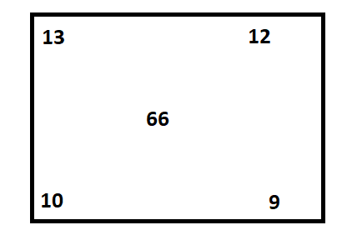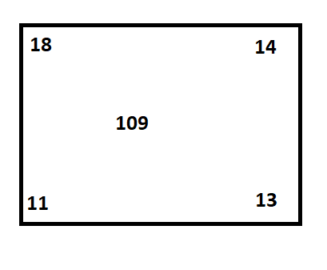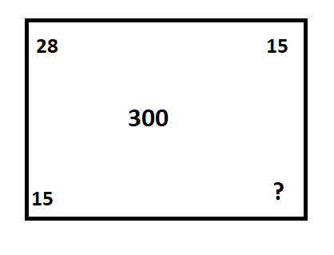

1. 14 C. 12
2. 8 D. 10

**In the code:**

‘R+S’ means ‘R is neither smaller than nor equal to ‘S’

‘R-S’ means ‘R is not greater than ‘S’

‘R➗S’ means ‘R is neither greater than nor smaller than ‘S’

‘R X S’ means ‘R is not smaller than ‘S’

‘R%S’ means ‘R is neither greater than nor equal to ‘S’

**Statements:**

O X P, P – A, A % Q

**Conclusions:**

1. **Q + P**
2. **Q** ➗ **P**
3. Only Conclusion I is true
4. Only Conclusion II is true
5. Either Conclusion I or Conclusion II is true
6. Neither Conclusion I nor Conclusion II is true.

What is the position of Suji in the line from the right end of the row?( Data arrangement)

1. Suji is 12th among the girl from the left end of the row.
2. Munna is 6th among the boys from the right end of the row.
3. In between Suji and Munna, there are 10 Students.
4. (ii) and (iii) only C. (i) and (iii) only
5. All (i), (ii) and (iii) D. Cannot be determined

A solid cube is painter blue on all its faces and is then cut into 64 smaller equal cubes. How many of these smaller cubes have none of their faces painted? (cubes and dices)



1. 8 C. 4
2. 10 D. 12